NOTICE
PUBLIC HEARING
FY 2024/25 RECOMMENDED BUDGET
OF THE GENERAL MANAGER
TUESDAY, MARCH 12, 2024
7:00 PM
LINCOLN CENTER
494 MAIN STREET

TOWN OF MANCHESTER, CONNECTICUT
FY 2024/2025 GENERAL MANAGER’S BUDGET MESSAGE

 | Adopted 2023/24 | Manager's Recom. 2024/25 | Percentage Change | Reclassify Costs & Revenues* | Adjusted Percent Change
Fund
General Fund – General Government | $ 7,110,575 | $ 7,663,157 | 7.77% | $ 7,940,217 | 11.67%
General Fund – Public Works | $ 14,659,169 | $ 15,328,532 | 4.57% | $ 16,240,638 | 10.79%
General Fund – Public Safety | $ 46,782,659 | $ 49,954,805 | 6.78% | $ 41,987,705 | -10.25%
General Fund – Human Services | $ 3,589,633 | $ 3,852,002 | 7.31% | $ 3,793,833 | 5.69%
General Fund – Recreation/Library | $ 6,790,898 | $ 7,202,187 | 6.06% | $ 7,357,130 | 8.34%
Non-Education Operating Subtotal | $ 78,932,934 | $ 84,000,683 | 6.42% | $ 77,319,523 | -2.04%
General Fund – Non Operating & Debt | $ 27,246,612 | $ 31,596,617 | 15.97% | $ 38,947,443 | 42.94%
Education Related Subtotal | $ 123,187,062 | $ 127,971,728 | 3.88% | $ 127,971,728 | 3.88%
General Fund Total | $ 229,366,608 | $ 243,569,028 | 6.19% | $ 244,238,694 | 6.48%
Information Technology | $ 2,359,427 | $ 2,877,725 | 21.97% | $ 3,141,797 | 33.16%
Water Fund | $ 10,164,019 | $ 11,384,362 | 12.01% | $ 11,354,362 | 11.71%
Sewer Fund | $ 11,533,925 | $ 12,365,489 | 7.21% | $ 12,395,489 | 7.47%
Sanitation Fund | $ 8,604,562 | $ 9,174,397 | 6.62% | $ 9,174,397 | 6.62%

March 5, 2024
Honorable Mayor Moran and Board Members:
2024 will be an exciting and transformative year for the Town of Manchester. Following many years of comprehensive engagement and planning, several projects that significantly enhance quality of life for residents will commence. From construction of the long-awaited 21st century library, to finalizing elementary school renovations, to major investments in parks and recreation, the repurposing of schools, economic development initiatives moving forward, to the on-going revitalization of Downtown, the FY2025 budget period will be a time of Building A Better Manchester.
It is with that sense of excitement that I present the FY2025 budget. This spending plan continues Manchester’s proud tradition of being financially sound while providing the necessary resources for important programs and services for our great residents.
The submission of the Town Manager’s proposed budget marks the culmination of a collaborative, multi-month process during which all departments provided input on anticipated personnel and operating expenses in the coming fiscal year.
As Manchester continues to grow, the goal of this 2025 budget recommendation is balancing the needs of the community, expectations of Manchester residents, and the obligation to develop a financing plan that is fiscally responsible. It builds on prior year’s investments in our Town’s provision of basic city services and public education, while ensuring the on-going support for the community’s most vulnerable populations.
Notable investments in this budget include:
- Board of Education increases 3.89% or $4.78 million in Manager’s recommended budget, based on the actions of the Board of Education.
- In response to increasing public safety demands, this budget invests in an additional Assistant Fire Chief and an additional police patrol officer, while also continuing to fund police transparency initiatives.
- In response to increased regulatory enforcement needs, the budget also invests in a new Property Maintenance Code Enforcement Officer.

- Human Service and Equity investments (previously funded by ARPA)
  - Early Childhood Engagement Specialist
  - part time Senior Center bilingual assistant
  - Health Equity Worker
- Critical city service programs (currently funded by ARPA)
  - police body cameras & cruisers,
  - the Town’s MS365 network operating system
  - reducing the ARPA subsidy of capital improvements from $1M to $520,000.
- Increasing assistance to community agencies by roughly $50,000 to ensure Manchester’s most at-risk residents can receive the support services they need.
Other highlights of the FY25 budget:
- Debt service increases by $1.9M, reflecting the first major installment of funding for construction of the new library as well as recurring public infrastructure and roadway investments.
- Retiree health & pension costs increase by $1.4M in accordance with actuarial valuation of those benefits programs.
As we approach a year out from the official end of federal COVID-19 emergency declaration, the lasting impacts of the pandemic remain. On the positive side, the Town will be leveraging state and federal funding to begin work on the major capital projects identified above.
Yet the lingering impacts of a once in a century public health crisis still present challenges at the local level. Most importantly, many residents, especially those most vulnerable, are struggling with the physical, mental, and economic challenges exacerbated by COVID-19. The demands placed on government services to address the challenges have yet to recede. As a result, the FY25 budget continues investments in public health, education, and public safety to ensure Manchester emerges stronger, more resilient, and more equitable than it was in 2020.
Moreover, not only have service demands increased, but so has the cost of providing them. As every resident is acutely aware, the price of nearly everything- from groceries to gas to consumer items-has risen dramatically over the last few years. This impacts households, but the inflationary pressures also affect municipal operations as wages, service contracts, supplies, and equipment are also growing in costs. It is for this reason that the Manager’s Recommended budget contains a mil rate increase above historical levels.
Over the last four years, the average mil rate increase in Manchester is 0.98%. Justifiably, during the pandemic emergency, the Board of Directors made it a priority to limit the financial burden of taxpayers while maintain or even increasing service levels. Unfortunately, due to inflationary pressures, the projected costs of providing these current service levels have far outpaced the Town’s existing revenues. While the Town’s largest revenue source, the property tax, has increased by less than 1% annually, and it’s second largest revenue source, direct state aid, has remained flat, the consumer price index (CPI) in Connecticut over the last three years has increased, on average, by over 5%.
It is important to note that, in comparison to many of our neighboring communities, Manchester town government provides its high-class level of service at relative low cost.
Over the past few budget cycles, and in response to the COVID pandemic, the Town has been able to keep the tax rate flat or very limited increases without impacting operations, largely due to the one-time influx of federal Covid funds.
The past four budget cycles- which produced 0% mil rate increases in FY21 and FY22, 0.93% in FY23, and 2.99% in FY24- identified most of the expense reductions that don’t substantially impact service levels. In today’s inflationary environment, however, the lack of raising additional revenue in previous budget years has significantly raised the cost of continuing current service levels. Moreover, this past year presented the following financial headwinds:
- Increased costs for health care, debt service and our required contributions to the pension fund.
- To address recruitment and retention issues, Board approved collective bargaining contracts have seen wages and benefits increasing more than the usual 2% GWI.
- Inflation and supply chain constraints will continue to increase costs of materials, supplies, and contracted services.
Consequently, this budget recommendation contains a 5.83% increase in the mil rate to sustain the Town’s existing operations. If you combine this recommended mil rate increase with the previous four years, it produces an average mil rate increase of over the last five years of 2%.
The drivers of the expenditure increase are as follows:
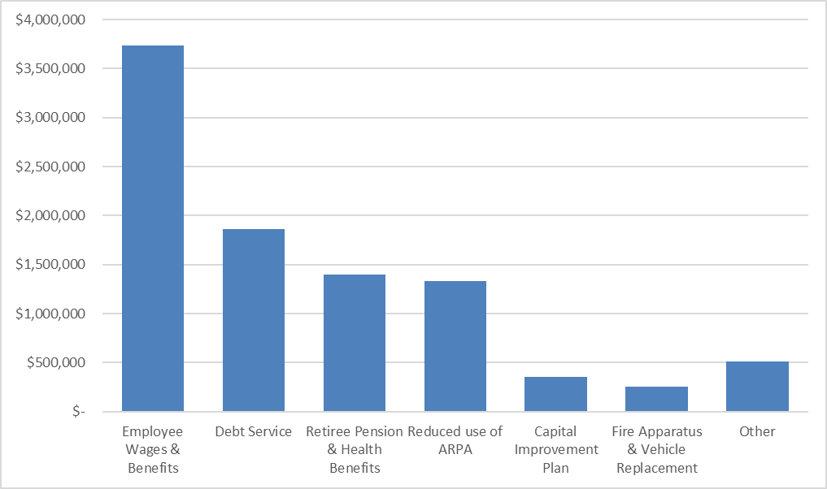

The result is a recommended General Fund budget of $243,569,028. This is an increase of $14,202,420 or 6.19% over the FY24 General Fund budgeted expenditures.

Prudent policies by the Board in prior years (negotiating changes to health care plans and investing in energy efficiency projects) have mitigated some of the cost pressures on the expense side of the budget. For example, despite a substantial increase in per-unit utility costs, we've been able to hold utility budgets relatively flat due to the implementation of energy-efficient technologies, particularly LED lighting.
Moving forward, the available policy options are to 1) increase the mil rate to maintain service levels or 2) maintain existing tax rate while eliminating certain programs and services.
Considering Manchester’s population growth and the increasing demand for services, there is an argument that the FY25 budget should be adding more resources to address human service, public safety, education, and parks and recreation needs. Budgets, to be sure, are policy priorities in action that must recognize the tradeoffs between service demands and the community’s ability to pay for them. The Town Manager’s budget is an initial policy recommendation that attempts to balance these two competing dynamics. It will ultimately be up to the community’s elected representatives, the Board of Directors, to decide on the final spending plan for the upcoming fiscal year.
In conclusion, it is my pleasure to respectfully submit to you the Town Manager’s Proposed Budget for the fiscal year beginning July 1, 2024, and ending June 30, 2025. This annual budget represents the spending plan that fully funds the services that make Manchester a place where people of all ages and backgrounds want to live, work, play, go to school, and raise a family. It invests in education, public safety, social equity, technology, and sustainability, without compromising the quality-of-service residents and businesses expect from their local government. In addition, this budget seeks to preserve Manchester’s AAA Credit Rating and prioritizes the long-term fiscal health of the Town.
It should be noted that several assistance programs are available for Manchester residents, especially those on a fixed income who are most affected to changes in property taxes. These include abatements for Seniors, Disabled Individuals, and Veterans.
I would like to thank the Mayor and Board of Directors for your leadership and guidance, your collaboration and partnership, as well as your visionary thinking about our community and the residents we serve. I am continuously impressed and grateful for the work of Town staff in service delivery to the community 24 hours a day, 7 days a week, 365 days a year.
In the coming weeks, I look forward to hearing more input from residents, businesses and not-for-profit organizations, and the Board, about their priorities for Manchester’s future, which I believe this 2025 Recommended Budget reflects.
Respectfully submitted,
Steve Stephanou
Town Manager

The budget also incorporates reorganization and simplification of some of the financial transactions between Town departments; after reclassifying some reimbursements to revenues, the revised total expenditures will be $244,238,694; this only represents an administrative change in accounting and does not affect the mill rate or total cost of services.

